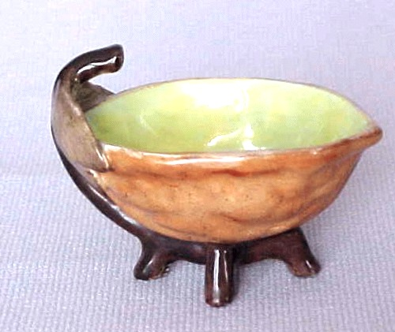
Salty Observations
No. 3 Winter 2002-3

Last fall we had an unusual salting adventure. About the middle of September, we got a call from the Martha Stewart Living organization. They wanted someone to appear with Martha in a discussion of open salts. We referred her to two people who we thought could do it well and let it go at that. A week or so later we got another call – neither of our recommended people could do it, and they had been convinced by them that they should get Ed Berg. We reluctantly agreed to drive to the studios in Westport, CT and bring some of our salts with us. We told them how open salts had evolved from about 1800 on, and they liked the idea of presenting the story. They arranged a hotel room for us to stay in, since this had to be an overnight trip.

On October 9, we packed up about 50 salts that represented the years from 1800 through the Martha Stewart salt being sold in Kmart today. We included pewter, silver, china, glass and even a wooden one (treen, to you purists). We checked into the hotel before lunch, grabbed a bite at the nearest Wendy’s and went hunting for the studio. It is out in the country, in a wooded setting like a park. You call in from the iron gate to be let in, then drive about 100 yards through a mature woods to a large house-like structure where the programs are produced. About 70 people work there full time, with half again that many coming in to run the cameras, lighting etc. when a program is being taped. The lady who had contacted us, Lenore Welby, met us at the reception desk and showed us to the studio. We were in one of the two kitchen sets, each made up to look like a kitchen in one of Martha’s houses. The layout and appliances were much bigger and better than anything we have at home, of course. We unpacked our salts on the big island counter and showed them what we had brought. They called in their artistic director to arrange them and she divided them into the appropriate (to her) categories – all the blue ones together, all the china ones, metal ones etc. We managed to get her rearrange them somewhat to match the historical evolution from masters to celery trays to modern collector items. During the afternoon several groups of people came to use other parts of the set to plan other program items. By the end of the day the salts were arranged and we had agreed on a general outline with the producer so that she could put together a script for the teleprompter. This was for Martha’s use, of course, we weren’t supposed to look at the cameras during the taping.
The next morning we showed up at 9:00 as instructed. This time the set was crowded with lighting, sound and camera people, most with headsets on. They use 4 cameras working simultaneously, with each viewing a different angle or having a different perspective on the action. The monitor shows all 4 of the camera pictures at once. They take about 10-15 minutes of “action” and edit it down to about 6 minutes for the final show. Martha had a group of her salts at the end of the counter where we started. It seems she doesn’t use shakers at all – she prefers open dishes! She is an enlightened lady!

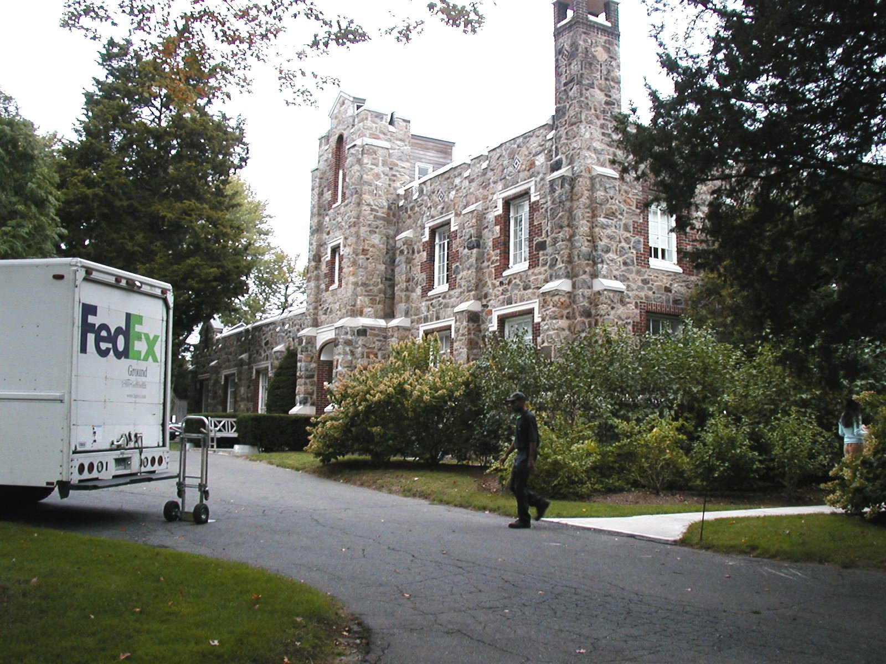
Martha Stewart Studio
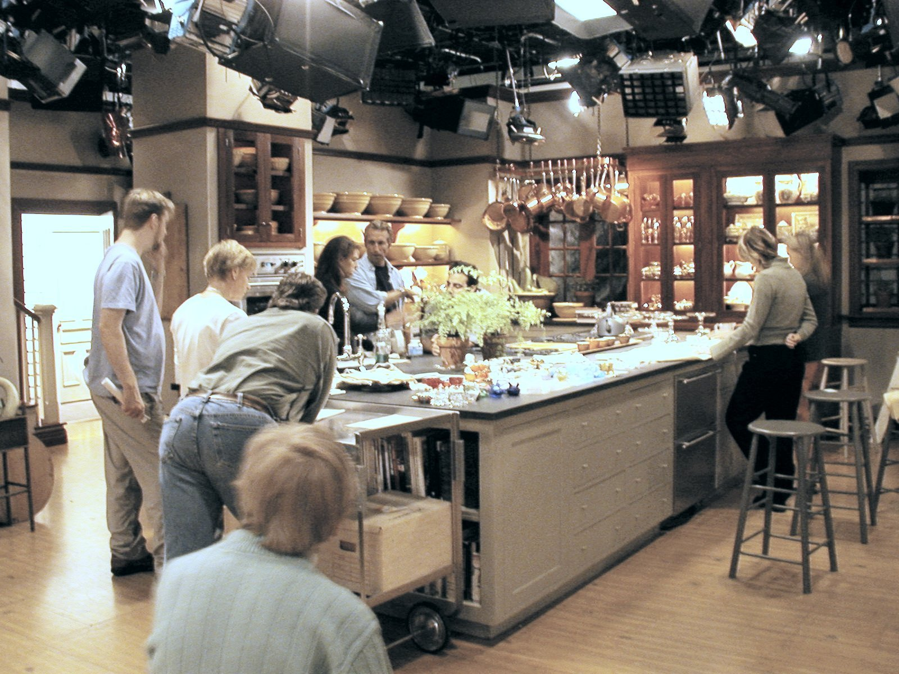
Kitchen Set
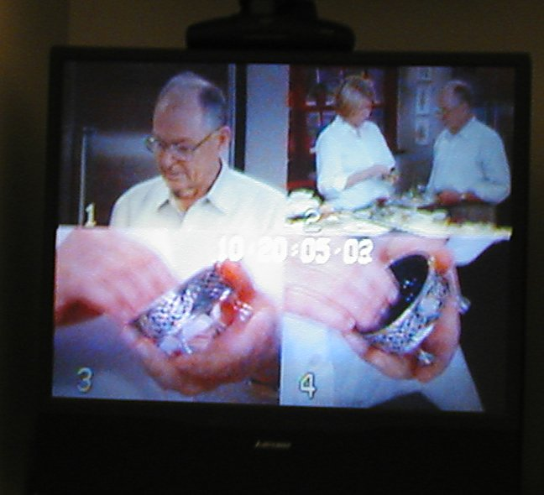
Monitor Picture

Hers are not all genuine salts – she had a pair of caster cups in the group. We asked her about them and found she knows what they are, but thinks they are fine for serving salt. That makes them open salts now, right? The historical angle or the maker’s ideas for their purpose are irrelevant.
About 10:30 the word was passed, “Martha is on her way”, and Kay was led away to a conference room to watch things on a monitor. Martha appeared and introduced herself, and we started talking about her dishes and ours. It was a conversation, with the cameras running and without any script. The teleprompter screen just below the camera lens had some questions for her to ask, but we don’t think it was ever used. We talked about the types of salts and the evolution of the shapes, and answered her questions for about 15 minutes or so – the time went very fast. When we reached the end, the producer asked each of us to do something over again – like point to a salt and say certain words we had used before. In a couple of cases we had to just say a line without the cameras being on. Evidently there are people watching each of the camera outputs and making sure that what is captured will be useful for the final editing. At the end Kay was brought back and participated in a picture-taking session.
After the performance we were given a tour of the facilities. They have a number of sets – dining room, pantry, gardening, and a craft room that looks like the A.G. Moore Craft Superstore. Everything that they might need for a demonstration is stored somewhere, from dishes for a formal dinner to spices, pans and flower pots. There are walls that can be moved into place for a backdrop – a different one was being rolled into place for the next taping after we were done. The programs are put together starting with brainstorming “what will we do next” sessions by the staff. This particular one evidently grew out of Martha’s use of open salts in her cooking and dining. The session immediately following ours was about various kinds of salt you can buy today – they had 5 or 6 different types ready. They all looked coarse and somewhat damp – not the kind that would work in any of our shakers. When we saw the show later we learned they were all derived from sea water.

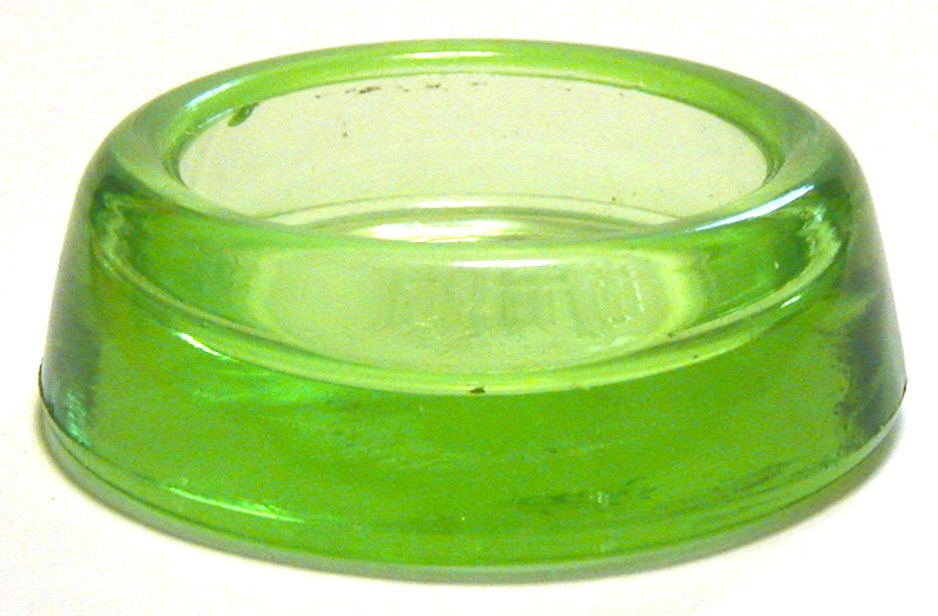
Caster Cup Salt
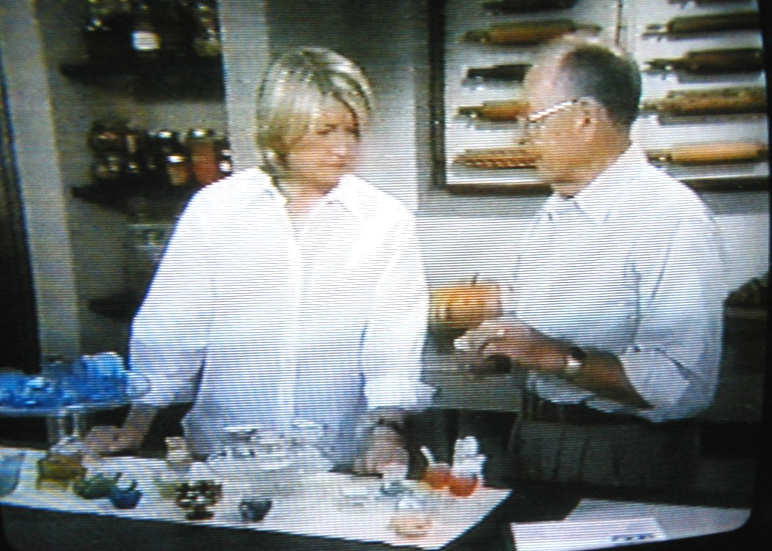
Doing the Program
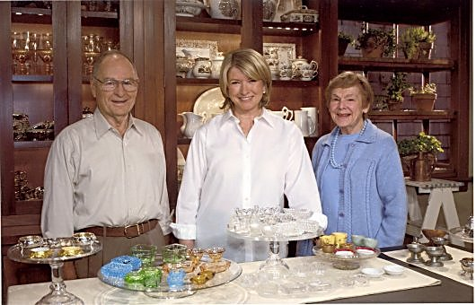
Martha and Friends
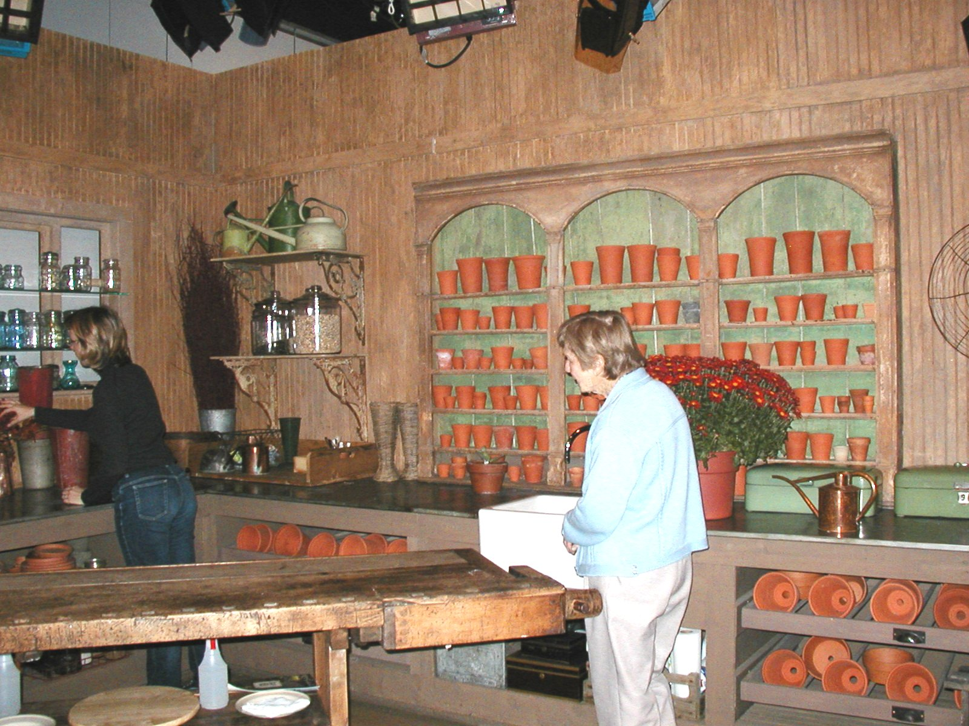
Gardening Set

The people who work in the organization were all very nice and very thoughtful. Most are young women (surprise!), and everyone seems to be quite busy. A couple of times someone appeared to hand out pieces of cake or some other goodie, and we were told that we could find beverages at the coffee station whenever we felt like it. They gave us copies of their recent magazines to take home with us. They promised to send us a tape of the final show, and called us the day before it was broadcast to make sure we remembered the date.. Unfortunately the local TV station shows it at 2:05 AM, but we set the alarm and also taped it just in case

The show with the open salts segment aired on November 12th. The producer called us the night before to be sure we remembered. It showed a copy of our Salty Comments and mentioned that we would send a sample copy to anyone who asked – details on Martha’s web site. Starting that afternoon we were deluged with requests and questions. There were over 100 emails, most asking about the sample copy for themselves or a relative, but some asking questions about a salt or salts they had. We spent much of the time for the rest of the week responding. We told all of the people who wrote about the central web site that Debbi Raitz manages (WWW.OPENSALTS.INFO), which gives a complete picture of the books available, the clubs and the upcoming Convention. How many will choose to become involved on a continuing basis remains to be seen. We don’t think that Martha Stewart will join any of our clubs, but maybe one of her employees has a few salts that are being passed down through the family and will get interested.

The adventure was very fascinating and a lot of fun. If any of you ever get an opportunity to talk about our activities on TV, take it. Spreading the word will uncover a lot of open salt collectors who have not heard about our organizations and will help keep our hobby alive.

Ed Berg November 2002

