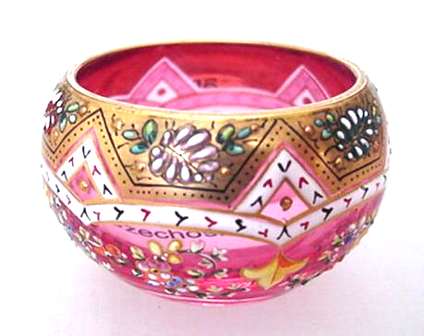
Salty Observations
No. 1 Spring 2002
}
In October, the New England club held its meeting at the Frank Chiarenza Museum of Glass in Meriden, CT. Frank is a glass collector who has collected enough interesting material to put it on display to the public. The Museum is well worth visiting if you are in Meriden, especially if you like seeing a wide variety of old glass. Frank is a very interesting guy to talk salts with. He told us a new (to us) way to tell the difference between the old Flying Fish salt and the L.G. Wright repro.
The original of these salts was made by an unknown company. We have seen only a milk glass version, sometimes painted. Whether the unpainted versions were originally sold that way or just lost their paint over the years, we don’t know. Around 1950, L.G. Wright had a new mold made which copied the original almost exactly. We have been telling the difference between new and old by looking at the base – the old one touches the table at 4 points while the new one sits flat. Frank pointed out that there is an easier way, The old one has an eyeball – a dot in the middle of the eye. We looked, and the difference is easily seen. Live and learn. – there is often a better way to do things than we first believe.
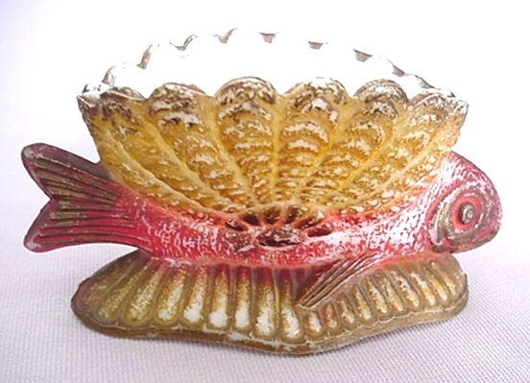
Flying Fish Salt
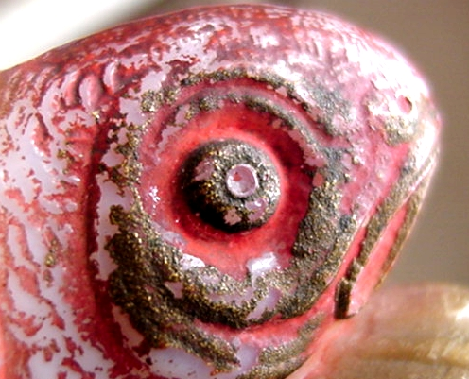 |  | 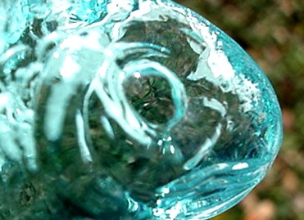
Old Fish |  | Wright Fish
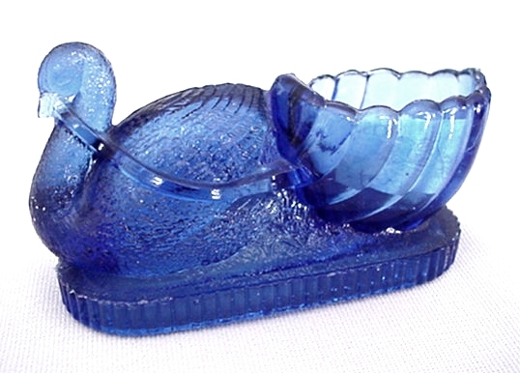 | 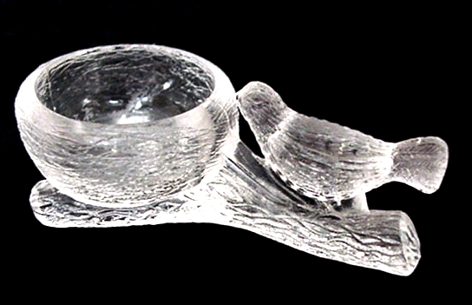
Swan Boat | Bird on Branch
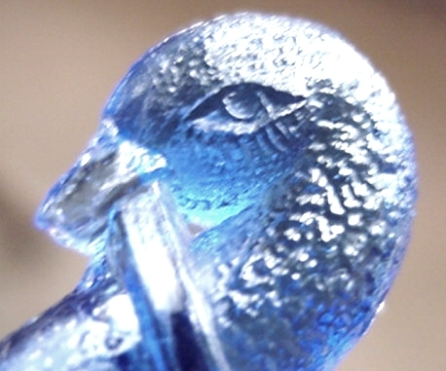 | 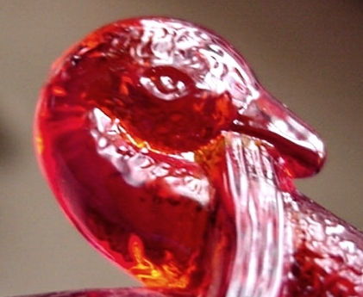
Old Mosaic Glass | New St. Clair
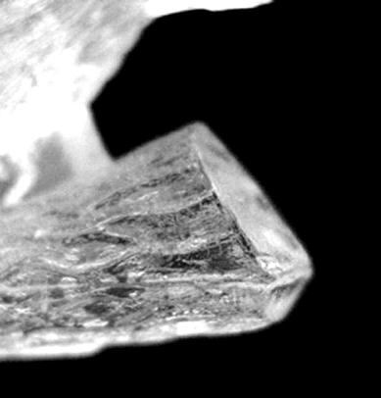 | 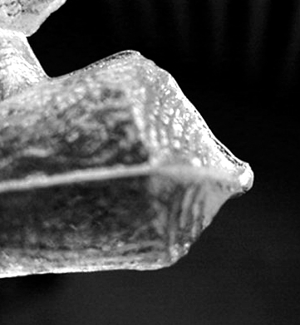
Old Branch End | New Mosser
This idea started us looking at bird eyes. We examined the Swan Boat, where the Joe St. Clair version is very close to the original. There may be a little difference, but it’s too small to be a good identifier. For the present, we’ll keep on using the other signs. The St. Clair one has grooves in the reins and the old one doesn’t. The old comes only in clear, blue, amber and maybe vaseline color as far as we can determine, so other colors are newer. We worry about the grooves identifier, though – if the glass is too cold they might not show up in a new one.
We also looked at the bird on branch salt, which Mosser has made for years. Here again the eyes are a little different, but the stub end of the branch is much easier to use as a sign. The old one has upper and lower flat surfaces on the end, while the Mosser one comes to a point and has wood grain.
We hope you have both old and new versions of these salts to compare for yourselves. If you remember these clues, you can tell the old from the new when you are in the dark and dusty back room of an antique shop and see one for sale at a ridiculously low price.
Ed Berg

