Mossy Comments - #7

Some collectors try to keep the size of their collection under control by specializing in one particular type of open salt. We know people who specialize in lacies, intaglios, masters, or salts decorated with a particular flower like roses or violets. There is another area we enjoy that nobody we know of has focused on – Scenery.

Most of the scenic salts we know are porcelain. The Japanese made quite a few of them during the Nippon era (1891-1921). During this time their china decorators were highly respected artists and very talented. We have seen quite a few different shapes with Japanese scenes like the first picture. Less common are lake scenes with a boat, like the next two shown. The desert scene doesn’t look like anything we have seen on television, and suggests to us that it was painted using the imagination rather than from real life. The winter scene on the next salt reminds us of some Daum Nancy salts we have seen – a prominent tree with snow and appropriate flora and fauna. The first 4 of these salts are marked and are from the Nippon era. We suspect the fifth is also, though it is not marked.

The Japanese are not the only ones who have made scenic salts, however. The best known of the European scenics are the Royal Bayreuth. We show one with a man and donkey and another with turkeys. These are definitely hand painted. We have seen a set of turkey salts, and there are tiny differences from one salt to the next which you would not see if the pictures were decals.

After 1921, Japan still made hand-painted scenic salts like the luster ware one with the blue sky. The painting is not as detailed on these later .ones, and some have the design outlined by a decal with only the color filled in by hand. There are also several shapes with decals of the Capitol in Washington. DC, undoubtedly made for sale as souvenirs. The rim decorations look like hand painting.

There are also scenic intaglio salts like the sailing ship, but that’s another story.

Ed Berg May 1999

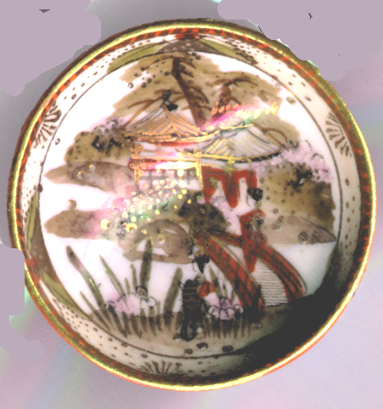 | 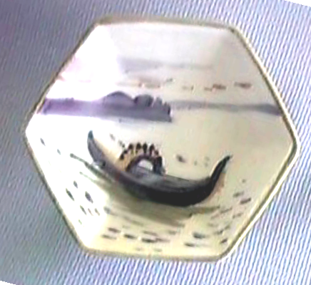
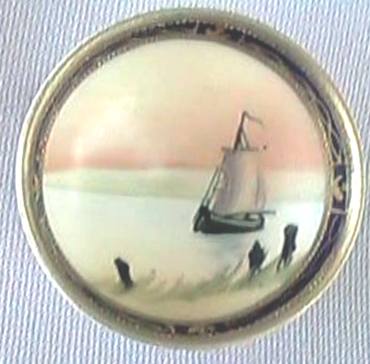 | 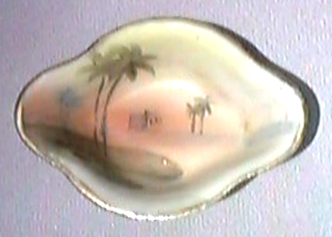
 | 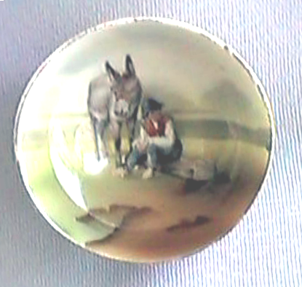
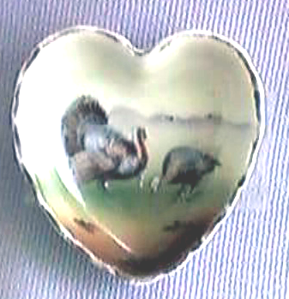 | 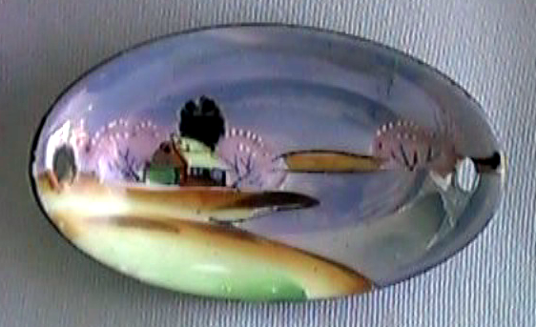
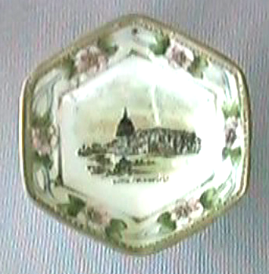 | 

