Mossy Comments - #6
The Christmas card wished us Happy Holidays, and the writer added “Hope you find that Special Salt in the New Year”. It started us thinking, “What would it be if we found it?”. Then we started wondering, “What are the Special Salts we have already?”.
We decided to identify our Special ones to clarify the point. Ed made a list of 12 that were memorable to him. Kay went to the collection and started putting hers on the dining room table. Ed stopped her after 24, though she protested she wasn’t finished yet. None of the ones she chose were on Ed’s list! After some discussion, we agreed that 10 of them deserve the designation, with a proviso that they aren’t the only ones. Here they are in no particular order:

Figure 1 is a pair of pewter salts we bought from Eleanor Thomas, a lovely New Hampshire lady, since deceased. They are engraved with initials and 1840, the year they were given to someone. Figure 2 is ruby glass with white glass dots on it and a matching spoon. It is one of our earliest purchases and still one of our favorites.
Figure 3 is a small blown glass pedestal salt in satin black. We found 6 of them 10 years ago and sold all but one. Figure 4 is the BANDED STAR master. We searched for it for years before Cackey Marsden found it for us at the Karpen’s booth in Adamstown.
Figure 5 is a gift to us from Ruth Darmstadt. We helped her sell her collection, and she gave us this as a big reward we didn’t expect. Figure 6 is our most elegant salt, which came as part of a collection from Ohio. It has about 200 tiny jewels (garnets?) mounted on the frame.
Figure 7 is made of oak. Our son, John, turned it for us when he bought a wood lathe. Figure 8 is a square jasperware salt by Wedgwood. We bought a pair, and sold the second one to the first person that saw it.
Figure 9 is an extremely scarce rectangular Wavecrest salt by Monroe. The Ayers found a pair during a trip through New England and we asked, “Can we buy one?” without even talking about the price. Figure 10 is a ruby red double joined by a knife rest which we bought with the Tompkins collection.
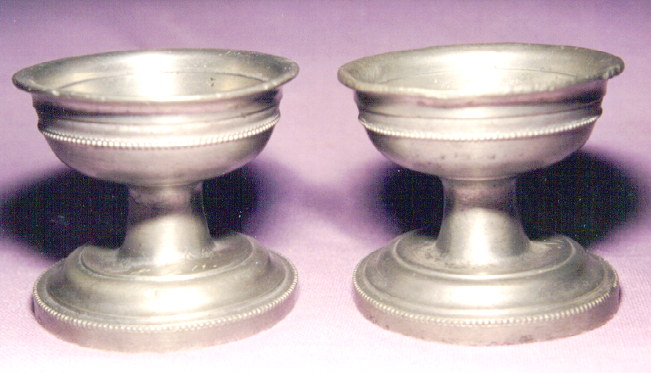 | 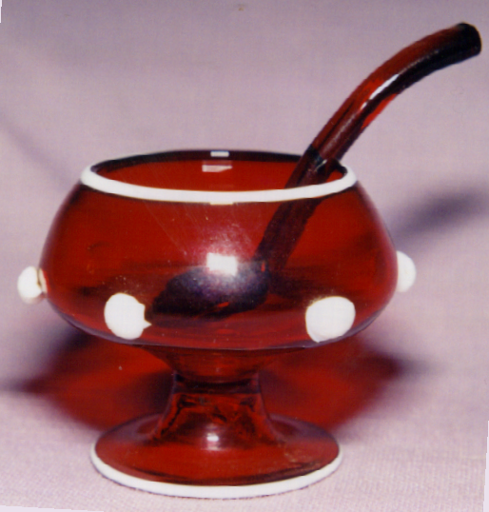
Figure 1 | Figure 2
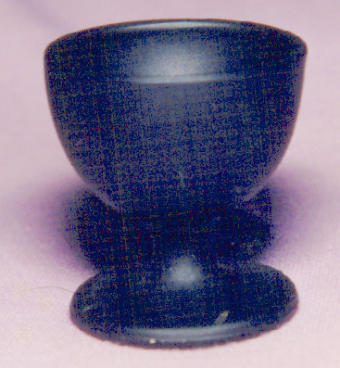 | 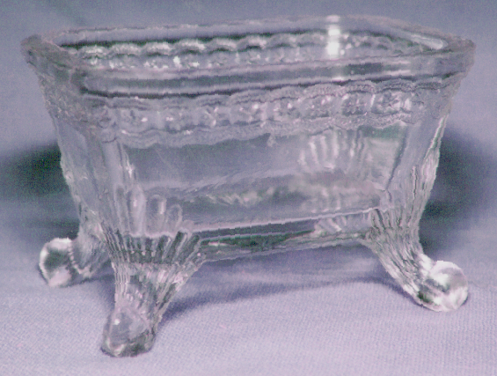
Figure 3 | Figure 4
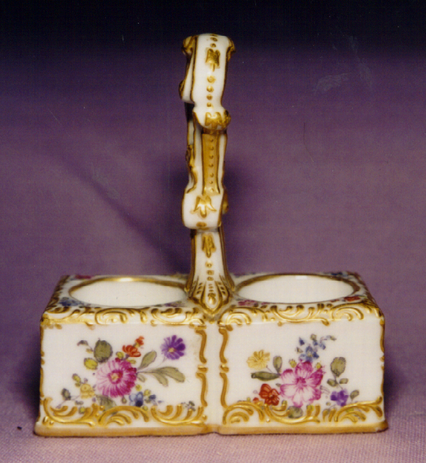 | 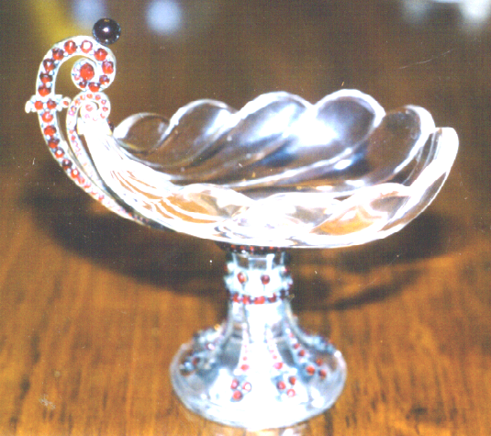
Figure 5 | Figure 6
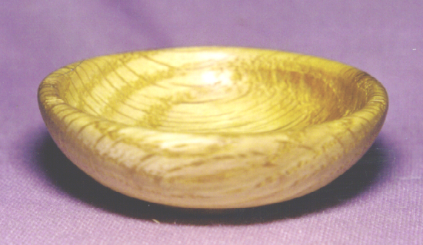 | 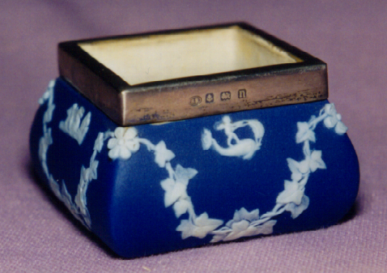
Figure 7 | Figure 8
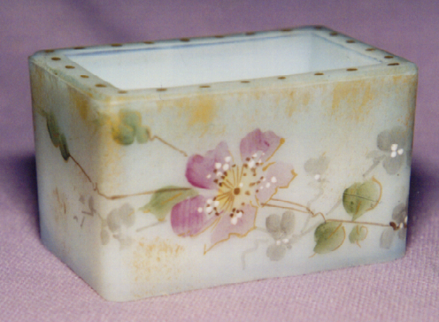 | 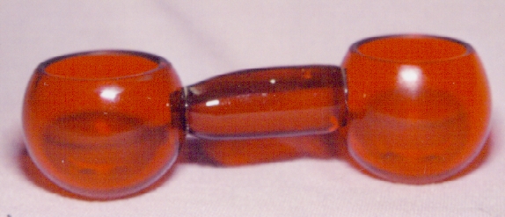
Figure 9 | Figure 10

So what makes a salt “Special”? Sometimes it’s how we got it, sometimes it’s who we got it from, sometimes it’s how it looks. A few of our Specials we hunted for, but most are ones we didn’t know about until we saw them. They are the first ones we would rescue if there was a fire and we had to get out fast.
What are your “Special” salts? What salt would you most like to find this year? Why not send a note to Ed Bowman telling about them, with pictures if you can. Sharing is one of the fun things about having a collection.
Ed Berg January 1999

