CASC 10TH ANNIVERSARY SALT 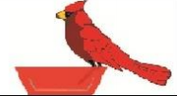
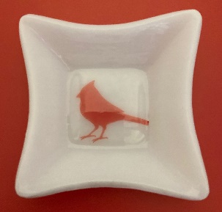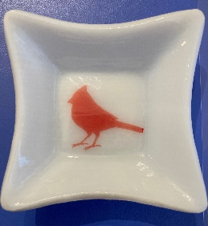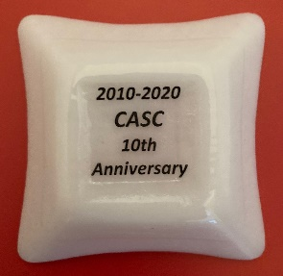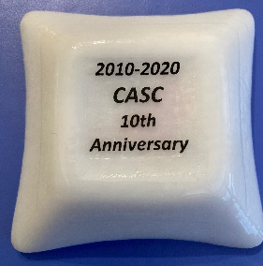
This beautiful salt is handmade and designed by Judy Johnson.
The salt is a slumped square salt with Cassie the cardinal, who is the CASC mascot, in the center of the bowl. The bottom is marked with the dates ‘2010-2020’ and ‘CASC 10th Anniversary’. The salt is about 2 ¾” square and a little less than 1” deep. These salts vary slightly in color and size because they are handmade, even the white glass is handmade! ……………………………………………………………………………………………………………
Order Form
To purchase this salt, please mail this completed form with a check payable to CASC to George Kullgren, 711 Norfield Court, Westminster, MD 21158.
I will pick up my salt(s) at the 17th National Open Salt Convention in Warwick, RI. I enclose $17.00 each for __________ salts.
Please send me my salt(s) now. I enclose $17.00 plus $6.00 S/H ($23.00 each) for ___________salts.

Name______________________________________________________

Address_____________________________________________________

Phone & Email________________________________________________

